

**Capstone Project – Movie rental analytics**



**Madhav R. Yawale**

**OVERVIEW**

The DVD rental market is a competitive landscape, demanding a deep understanding of customer behavior, film performance, and staff efficiency. This project tackles this challenge by harnessing the power of data analytics to guide informed decision-making. Through Exploratory Data Analysis (EDA) and SQL queries, we'll uncover hidden gems in the data, revealing trends, patterns, and opportunities for improvement across customer behavior, film inventory, staff performance, and store operations. Visualizations in an Excel file will translate these insights for clear understanding.

Furthermore, a comprehensive Power BI dashboard will be constructed, transforming raw data into actionable intelligence. This dashboard will provide a window into customer segmentation for targeted marketing campaigns, sales trends to optimize film inventory, film performance to unearth hidden gems, staff productivity for targeted development, and ultimately, data-driven decisions for maximizing store revenue. By leveraging the dashboard's clear recommendations for targeted marketing, film collection enhancements, and staff training initiatives, DVD rental store owners can make informed decisions, optimize operations, and thrive in a competitive market.

**THE PROCESS**

1. **Data Acquisition from Github**: -

The project utilized a public GitHub repository containing movie rental data. This data included customer details and information on film categories rented. After verifying public access, the data was downloaded in formats compatible with chosen analysis tools: SQL Script for database queries and Power BI for visualizations.

1. **Data Transformation and Cleaning: -**

This project tackles data quality and expands the analytical scope. It ensures data integrity by managing missing values, addressing outliers, and rectifying inaccuracies. Furthermore, introducing new problem statements broadens the investigation, uncovering a wider range of insights and maximizing the potential for data-driven discoveries.

1. **MECE Approach:-**

Leveraging MECE analysis, this project will systematically dissect the data. This approach ensures a comprehensive evaluation, uncovering valuable insights and patterns across all relevant dimensions.

1. **Connecting With Tools: -**

Integrate the dataset with MySQL for robust database management and querying capabilities. Utilize Power BI as a dynamic visualization tool, enabling seamless data processing and insightful reporting. This connection enhances the analytical workflow, allowing for efficient data integration and comprehensive analysis.

1. **Exploratory Data Analysis (EDA) :-**

Exploratory Data Analysis (EDA) with SQL involves crafting specific queries to extract and analyze data. This process uncovers meaningful patterns, relationships, and trends within the dataset. These insights then become the foundation for informed decision-making.

1. **Problem Statement Solution In Power BI:-**

Power BI transformed into a platform for tackling diverse business challenges. Employing a variety of charts and visualizations, the data was effectively represented. Through manipulation and analysis, key insights and trends emerged, revealing valuable information to guide decision-making.

1. **Detailed Documentation :-**

The project lifecycle was thoroughly documented, covering key phases: data collection from GitHub, comprehensive transformation and cleaning, Formulation of MECE breakdown,formulation of problem statements, seamless tool integration (MySQL and Power BI), insightful Power BI solutions, Exploratory Data Analysis (EDA) for meaningful insights.

**OBJECTIVE**

**1. Data Deep Dive:** A meticulous exploration of the dataset will be conducted to understand its structure and uncover hidden relationships. This paves the way for in-depth analysis.

**2. Customer Segmentation and Profiling:** Customers will be segmented based on rental habits, preferences, and demographics. Detailed customer profiles will be created, empowering targeted marketing strategies and personalized recommendations.

**3. Film Performance Analysis:** Film performance will be rigorously analyzed. Top performers will be identified, their popularity assessed, and strategies recommended for film selection, promotion, and revenue optimization.

**4. Staff Productivity Assessment:** Staff productivity will be analyzed to identify high performers and pinpoint areas for improvement. Training or incentive programs will be recommended to boost performance.

**5. Store Operations Efficiency Analysis:** Operational data will be analyzed to identify bottlenecks and streamline processes. This optimizes efficiency and maximizes store revenue while considering cost control.

**6. Data Visualization and Storytelling with Power BI:** Informative and engaging visualizations will be created using Power BI to effectively communicate findings. This paints a compelling data-driven narrative for stakeholders.

**7. Informed Decision-Making for Rental Store Owners:** The project equips rental store owners with the insights and recommendations needed to make informed decisions. The goal is to empower them to thrive in the competitive movie rental market.

**SIGNIFICANCE**

**1. Data-Driven Decisions:** Empowering stakeholders with data-driven insights is paramount. Analyzing customer behavior, film inventory, staff performance, and store operations equips them to make informed choices that directly impact success.

**2. Customer at the Core:** Understanding customer behavior is key. Customer segmentation allows for personalized marketing strategies and improved satisfaction, fostering loyalty and driving revenue growth.

**3. Efficiency & Cost Optimization:** Optimizing film inventory and store operations directly addresses the need for efficiency and cost reduction. Identifying top performers, streamlining processes, and minimizing unnecessary expenses contribute to improved profitability and sustainability.

**4. Competitive Edge:** This project equips rental stores with a competitive advantage in a fierce market. Data insights, recommended marketing strategies, and staff performance enhancements empower businesses to outperform competitors and excel in the industry.

**5. Trustworthy Data Foundation:** Data quality and reliability are crucial. Through data cleaning and validation, the project not only enhances the analysis but sets a standard for data integrity in the industry, impacting other data-driven ventures.

**6. Transparency & Reproducibility:**  Transparency and reproducibility are embraced by documenting the entire process and methods. This sets a precedent for other projects, emphasizing the importance of open and transparent data analysis practices.

**7. Knowledge for All:** Insights and recommendations serve as valuable educational resources, educating stakeholders, staff, and the industry on the benefits of data analysis and data-driven decision-making.

1. **Stakeholder Empowerment:** Ultimately, this project empowers stakeholders with the knowledge and tools needed to succeed in the movie rental market. It serves as a catalyst for positive change and business growth. The project'ssignificance transcends the industry, highlighting the transformative power of data analysis, customer-centric strategies, and operational efficiency for any business.

**DATA DICTIONARY**

Dataset is a comprehensive collection of information from a movie rental service, encompassing a wide array of tables with details on actors, films, customers, rental transactions, & more. This rich dataset forms the foundation of my analysis, supplying insights into customer behaviour, film inventory management, & operations.

**Table Explanations:**

**Actor Table:** The actor table lists information for all the actors.

**•** Actor id (Primary Key): A unique identifier for each actor.

• first name: The first name of the actor.

• last name: The last name of the actor.

**Category Table:** The category table lists the categories that can assigned to films.

• Category id (Primary Key): A unique identifier for each category.

• name: The name of the category.

**Address Table:** The address table has address information for customers, staff.

• Address id (Primary Key): A unique identifier for each address.

• address: The street address.

• address2: Additional address information, if available.

• district: The district or area.

• City id (Foreign Key): A reference to the city table, standing for the city where the address is present.

• Postal code: The postal code.

• phone: The phone number associated with the address.

**City Table:** The city table holds a list of cities.

• City id (Primary Key): A unique identifier for each city.

• city: The name of the city.

• Country id (Foreign Key): A reference to the Country table, standing for the country or region where the city is present.

**Country Table:** The country table holds a list of countries or regions.

• Country id (Primary Key): A unique identifier for each country.

• country: The name of the country or region.

**Customer Table:** The customer table holds a list of all customers.

• Customer id (Primary Key): A unique identifier for each customer.

• Store id (Foreign Key): A reference to the Store table, showing the store where the customer registered.

• First name: The first name of the customer.

• last name: The last name of the customer.

• email: The customer's email address.

• Address id (Foreign Key): A reference to the Address table, specifying the customer's address.

• active: A flag showing whether the customer's account is active.

• Create date: The date when the customers created account.

**Film Table:** The film table lists all the films that may be in stock in the store.

• Film id (Primary Key): A unique identifier for each film.

• title: The title of the film.

• description: A brief description of the film.

• Release year: The year when the film released.

• Language id (Foreign Key): A reference to the Language table, specifying the film's language.

• Original language id (Foreign Key): A reference to the Language table, standing for the original language of the film.

• Rental duration: The rental duration of the film.

• Rental rate: The rental rate for the film.

• Replacement cost: The cost to replace the film.

• rating: The film's content rating.

**Film text Table:** The content of the film text table kept in synchrony with the film table by triggers on the film table INSERT, UPDATE, and DELETE operations.

• Film id (Foreign Key): A reference to the Film table, with film title.

• film title: The title of the film.

• description: A brief description of the film.

**Film actor Table:** The film actor table support many to many relationships’ films and actors.

• Actor id (Foreign Key): A reference to the Actor table, stands for the actor associated with the film.

• Film id (Foreign Key): A reference to the Film table, showing the film in which, the actor appeared.

**Film category Table:** The film category table support many to many relationships between films and categories.

• Film id (Foreign Key): A reference to the Film table, specifying the film associated with a category.

• Category id (Foreign Key): A reference to the Category table, showing the category assigned to the film.

**Inventory Table:** The inventory table is a copy of a given film in each store.

• Inventory id (Primary Key): A unique identifier for each inventory item.

• Film id (Foreign Key): A reference to the Film table, stands for the film in the inventory.

• Store id (Foreign Key): A reference to the Store table, showing the store where the inventory item is.

• last update: The date and time when the inventory item updated.

**Language Table:** The table lists all values for the film & original language.

• Language id (Primary Key): A unique identifier for each language.

• name: The name of the language.

**Payment Table:** The payment table records every payment made by the customer, including information such as the amount and rent paid.

• Payment id (Primary Key): A unique identifier for each payment transaction.

• Customer id (Foreign Key): A reference to the Customer table, specifying the customer who made the payment.

• Staff id (Foreign Key): A reference to the Staff table, showing the staff member who processed the payment.

• Rental id (Foreign Key): A reference to the Rental table, standing for the rental associated with the payment.

• amount: The payment amount.

• Payment date: The date and time when of the payment.

**Rental Table:** The rental table holds a row for each rental of each inventory item, which holds information about who rented what, when it rented it, and when it returned.

• Rental id (Primary Key): A unique identifier for each rental transaction.

• Rental date: The date and time when the movie rented.

• Inventory id (Foreign Key): A reference to the Inventory table, showing the inventory item rented.

• Customer id (Foreign Key): A reference to the Customer table, specifying the customer who rented the film.

• Return date: The date and time when the rental returned.

• Staff id (Foreign Key): A reference to the Staff table, standing for the staff member who processed the rental.

**Staff Table:** The staff table lists all staff information, including email addresses, login information, and pictures.

• Staff id (Primary Key): A unique identifier for each staff member.

• first name: The first name of the staff member.

• last name: The last name of the staff member.

• Address id (Foreign Key): A reference to the Address table, specifying the staff member's address.

• email: The email address of the staff member.

• Store id (Foreign Key): A reference to the Store table, showing the store where the staff member works.

• active: A flag showing whether the staff member is currently active.

• username: The staff member's username for system login.

• password: The staff member's password for system login.

• last update: The date and time of the staff member's last update.

**Store Table:** The store table lists all stores in the system.

• Store id (Primary Key): A unique identifier for each store.

• Manager staff id (Foreign Key): A reference to the Staff table, standing for the staff member who manages the store.

• Address id (Foreign Key): A reference to the Address table, specifying the store's address.

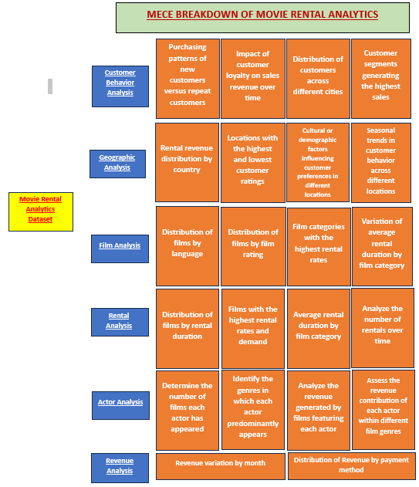

**ER DIAGRAM**

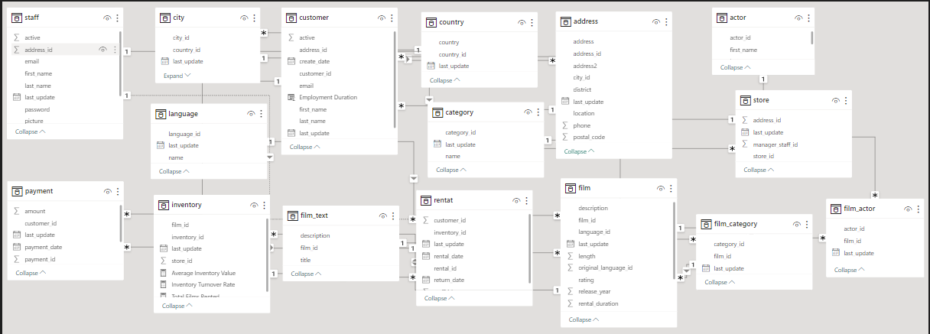

**EDA**

**Problem Statement 1 :-**

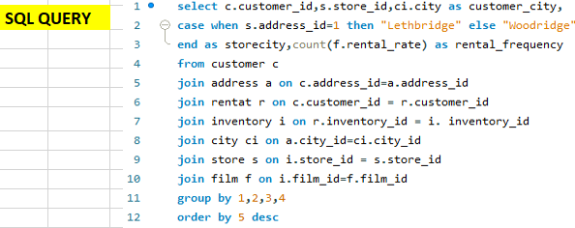How does the proximity of stores to customers impact rental frequency?

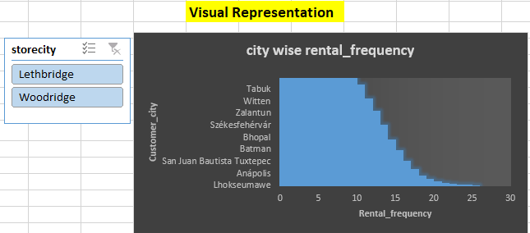

**INSIGHT:-**

The provided chart delves into the correlation between store proximity and rental frequency, particularly examining two specific locations: Lethbridge and Woodridge. The data suggests a clear trend wherein customers who reside closer to these stores exhibit a higher frequency of rental activity. This observation underscores the significant influence of convenience and accessibility on rental behavior. It implies that customers are more inclined to engage in renting when they have easier access to rental stores, highlighting the importance of geographical proximity as a contributing factor to increased rental activity.

**Problem Statement 2 :-**

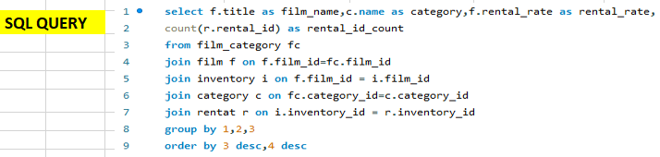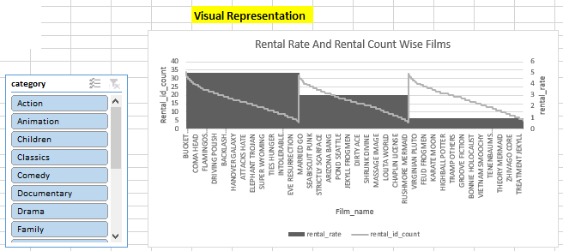Which films have the highest rental rates and are most in demand?

|  |  |
| --- | --- |
|  |  |

**INSIGHT:-**

The chart demonstrates a significant correlation between higher rental rates and heightened demand for films, indicating that customers are willing to pay more for movies they find appealing. Notably, "BUCKET BROTHERHOOD" emerges as a prime example, exhibiting both high rental rates and substantial demand. This insight suggests that analyzing popular titles like "BUCKET BROTHERHOOD" can assist rental stores in effectively prioritizing their inventory and marketing efforts, ensuring that sought-after films are readily available to meet customer preferences. By strategically promoting movies with both high rental rates and demand, rental stores can optimize their revenue potential while simultaneously enhancing customer satisfaction and engagement, thereby fostering a more profitable and sustainable business model.

**Problem Statement 3 :-**

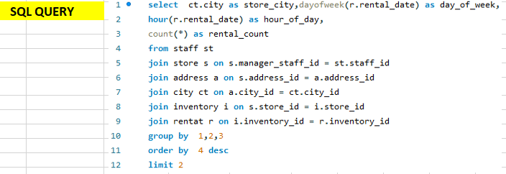What are the busiest hours or days for each store location, and how does it impact staffing requirements?

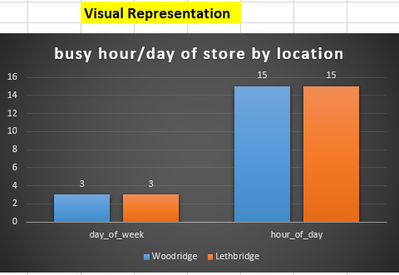

**INSIGHT:-**

The data provided indicates that on Wednesdays at 3:00 PM, both the Woodridge and Lethbridge store locations experience a peak in rental activity, with 144 and 140 rentals, respectively. This insight suggests that midweek afternoons are particularly busy periods for these stores. Understanding these peak hours is essential for optimizing staffing schedules to ensure adequate coverage during times of high demand. By aligning staffing levels with peak rental hours, store managers can effectively manage customer service levels, minimize wait times, and enhance overall customer satisfaction. Additionally, identifying and strategically allocating resources during these busy periods can optimize operational efficiency and maximize revenue generation potential.

**Problem Statement 4 :-**

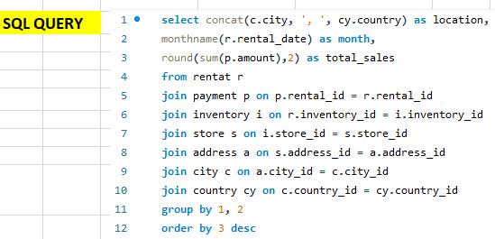Are there seasonal trends in customer behavior across different locations?

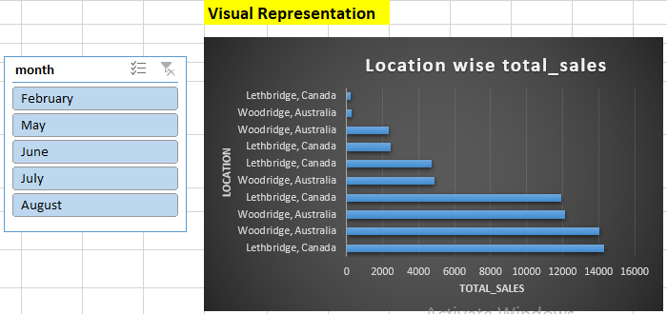

**INSIGHT:-**

The data analysis reveals that both Lethbridge, Canada, and Woodridge, Australia, exhibit discernible seasonal trends in customer behavior, with the highest sales volumes typically observed during the summer months. Despite this similarity in seasonal fluctuations, Lethbridge consistently surpasses Woodridge in terms of total sales figures. This discrepancy suggests the presence of potential variations in market dynamics or customer preferences between the two locations.

Further exploration and in-depth investigation into the underlying factors driving these differences could yield valuable insights for implementing tailored marketing strategies. Understanding the unique characteristics of each market and the distinct preferences of local customers is essential for maximizing sales potential and optimizing business performance in both Lethbridge and Woodridge. By leveraging these insights, businesses can develop targeted marketing approaches that resonate with the specific needs and preferences of customers in each location, thereby enhancing competitiveness and driving sustainable growth.

**Problem Statement 5 :-**

How does customer loyalty impact sales revenue over time?

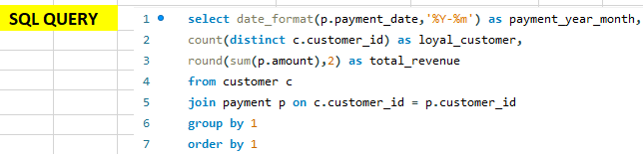

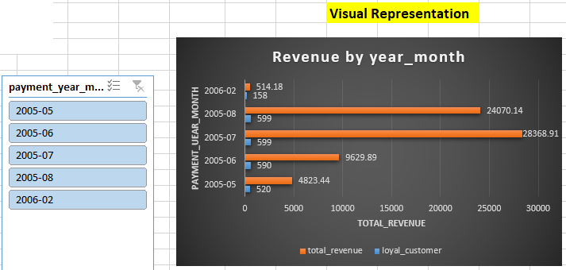

**INSIGHT:-**

The Data Suggest total revenue experiences fluctuations over time, the number of loyal customers remains relatively consistent. This consistency underscores the significance of customer loyalty as a stabilizing force in sustaining sales growth. Furthermore, observing seasonal variations in revenue presents opportunities for implementing targeted marketing and retention strategies, aimed at maximizing revenue during peak periods and mitigating declines during slower seasons. These insights collectively emphasize the critical role of fostering customer loyalty in driving long-term revenue success, as it serves as a foundation for maintaining a steady customer base and supporting business stability amidst market fluctuations.

**Problem Statement 6 :-**Examine Revenue variation by countries?

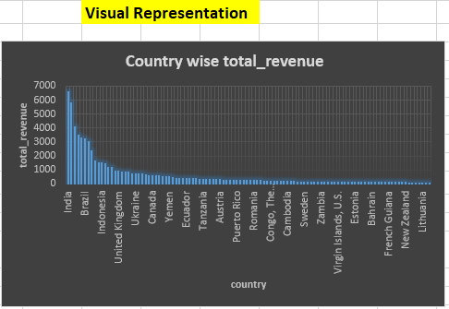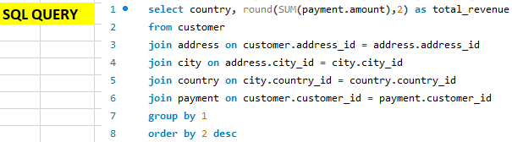

**INSIGHT:-**

The data provides insights into revenue variations by countries, showcasing the diverse financial contributions from different regions. Notably, countries like India, China, and the United States emerge as the top revenue generators, reflecting their significant market presence and customer engagement. This distribution underscores the global reach of the rental business, with revenue streams spanning across continents. Additionally, the revenue figures highlight potential growth opportunities in emerging markets like Brazil, Russia, and the Philippines, where rental activity appears promising but may benefit from targeted marketing efforts and service enhancements to maximize revenue potential. Understanding revenue disparities among countries enables rental businesses to strategically allocate resources, tailor marketing strategies, and prioritize expansion efforts to capitalize on lucrative markets while addressing challenges in others.

**Problem Statement 7 :-**

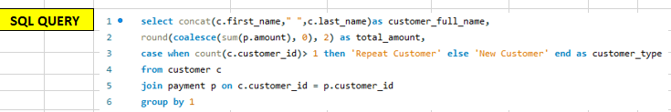What are the purchasing patterns of new customers versus repeat customers?

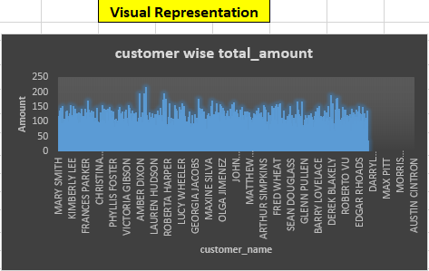

**INSIGHT:-**

The chart illustrates a heterogeneous customer base characterized by robust repeat business. While expenditure patterns vary among repeat customers, there's notable potential among new customers. Implementing targeted marketing strategies holds promise for augmenting spending among existing clientele and capturing new ones. Notably, repeat customers exhibit a tendency to spend significantly, with the highest spender among this group allocating $216.54. Conversely, the lowest spender among repeat customers recorded an expenditure of $33.89. This data underscores the importance of tailoring marketing efforts to maximize customer engagement and retention, ultimately fostering revenue growth.

**Problem Statement 8 :-**

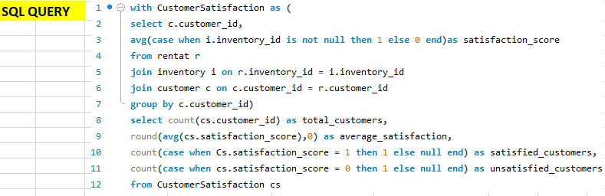How does the availability of inventory impact customer satisfaction and repeat business?

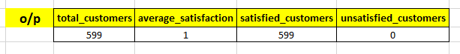

**INSIGHT:-**

The examination reveals a unanimous satisfaction among customers regarding the availability of inventory, suggesting a robust level of repeat business and a deep-rooted sense of loyalty among our clientele. This overarching positive sentiment not only underscores the efficacy of our service in consistently fulfilling customer requirements but also signifies a strong indication of sustained patronage in the foreseeable future. This alignment between customer expectations and service delivery underscores the foundational principles of our business, fostering enduring relationships and ensuring a positive customer experience journey.

**Problem Statement 9 :-**

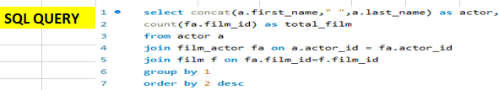which actor who appear in the most films?

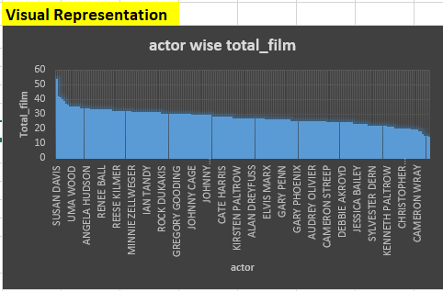

**INSIGHT:-**

From This Analysis It Is Seen That Susan Davis emerges as the lead actor with the highest total film count of 54, followed closely by Gina Degeneres and Walter Torn with 42 and 41 films, respectively. The data reveals a diverse range of actors, each contributing to varying extents to the film industry. It also showcases the prolific nature of certain actors, such as Mary Keitel and Matthew Carrey, who have appeared in 40 and 39 films, respectively. Additionally, there are insights to be gained from the distribution of film counts among actors, with some having notably fewer appearances, indicating potential differences in popularity or opportunities within the industry. Overall, this dataset offers valuable insights into the landscape of actors and their contributions to the film industry.

**Problem Statement 10 :-**

Calculate Total Films For Each Category?

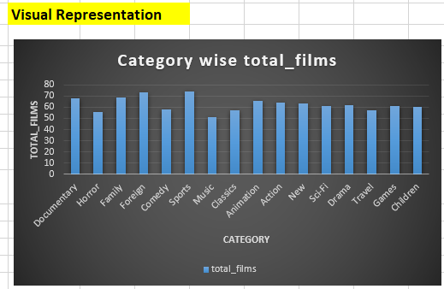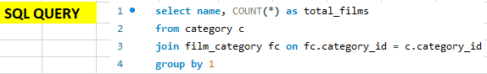

**INSIGHT:-**

The analysis of the dataset unveils a notable discrepancy in the number of films across different genres. Specifically, genres such as Foreign, Sports, and Family exhibit a significantly higher count of films compared to others. This observation suggests that there might be a strong demand or production emphasis on these genres within the film industry. Conversely, genres like Music and Classics appear to have a lower representation in terms of the number of films available. This pattern could reflect shifting audience preferences, trends in filmmaking, or the prioritization of certain genres by filmmakers and production companies. Further exploration into the underlying factors influencing these disparities could provide valuable insights into audience preferences and industry dynamics.

**Problem Statement 11 :-**

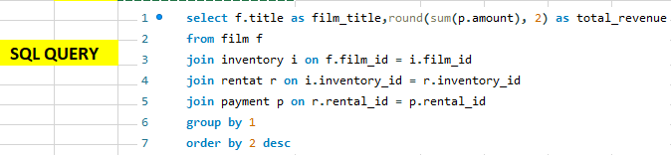Which films generate the highest revenue?

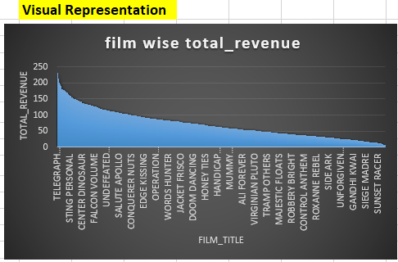

**INSIGHT:-**

The chart demonstrates film titles and their respective total revenues reveals that several movies stand out in terms of generating high revenue. Notably, "TELEGRAPH VOYAGE" emerges as the top earner with a total revenue of $231.73 million, followed closely by "WIFE TURN" with $223.69 million and "ZORRO ARK" with $214.69 million. These three films lead the pack in terms of revenue generation, showcasing their popularity and commercial success. Other notable high-revenue generators include "GOODFELLAS SALUTE," "SATURDAY LAMBS," and "TITANS JERK," each surpassing the $200 million mark. The consistent presence of these films at the top of the revenue chart suggests their widespread appeal to audiences, potentially driven by factors such as star power, compelling storytelling, and effective marketing strategies. Overall, these insights underscore the significant impact that successful films can have on the entertainment industry, both creatively and economically.

**Problem Statement 12:-**What is the distribution of films across different content ratings?

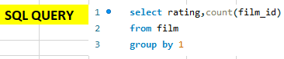

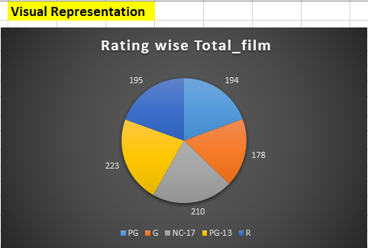

**INSIGHT:-**

The data reveals the distribution of films across various content ratings. Among the ratings, PG-13 has the highest number of films, followed closely by NC-17 and R-rated films. PG and G-rated films have slightly fewer entries compared to the other categories but still constitute a significant portion of the dataset. This insight suggests a diverse range of content available to audiences across different age groups, catering to varying preferences and sensitivities. Such diversity in content ratings allows rental stores to effectively cater to a broad customer base while ensuring appropriate viewing options for audiences of all ages and preferences.

**Problem Statement 13 :-**

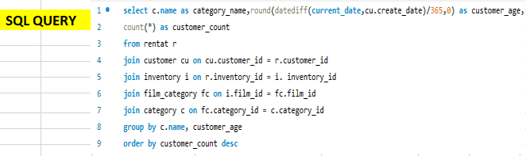Do specific film categories attract different age groups of customers?

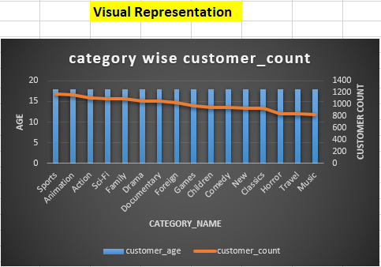

**INSIGHT:-**

The query output reveals a compelling trend wherein all film categories strongly resonate with customers aged 18. This finding underscores the pivotal importance of aligning content offerings with the specific preferences of different age demographics within the rental store's target audience. By leveraging this insight, rental stores can refine their marketing strategies and content curation efforts to effectively attract and retain younger audiences. Understanding the preferences of 18-year-old customers allows rental stores to tailor promotional campaigns and content recommendations accordingly, thereby enhancing customer satisfaction and fostering loyalty. Additionally, optimizing inventory management based on the popularity of various film genres among this demographic segment enables rental stores to maximize revenue potential and improve overall customer experience. Ultimately, recognizing the broad appeal of film categories among customers aged 18 positions rental stores to thrive in the competitive rental market by catering to the diverse preferences of this significant demographic cohort.

**Problem Statement 14 :-**

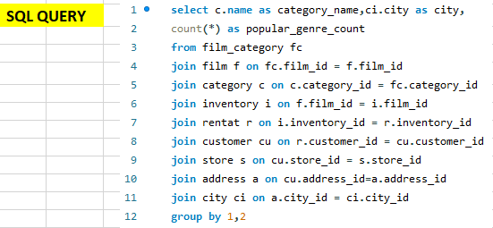Are certain film categories more popular in specific locations?

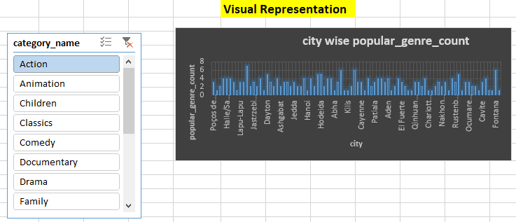

**INSIGHT:-** From This Analysis the popularity of action movies across various cities, several insights can be gleaned. Firstly, there appears to be a widespread interest in action films, as evidenced by the relatively high counts of popular action movies across a diverse range of locations worldwide. Cities such as Pontianak, Dayton, Bhilwara, Poá, and Fontana stand out with notably high counts of popular action movies, suggesting a strong affinity for this genre among their respective populations. Additionally, it's interesting to note that while some cities exhibit a consistent preference for action films, with relatively high counts across the board, others show more variability, with some cities having lower counts despite still featuring action movies among their popular genres. This variation could be attributed to factors such as demographic differences, cultural preferences, and the availability of alternative entertainment options. Overall, the data underscores the global appeal of action movies while also highlighting the nuanced preferences that exist among audiences in different cities. Understanding these patterns can inform distribution strategies, content creation decisions, and targeted marketing efforts to better cater to local tastes and maximize audience engagement in each location.

**Problem Statement 15 :-**

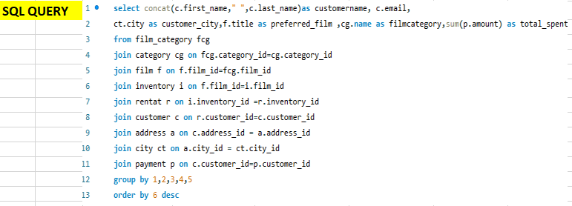What are the demographics and preferences of the highest-spending customers?

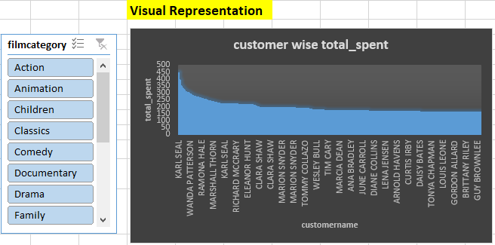

**INSIGHT:-**

The data analysis presents a comprehensive view of the film preferences among the highest-spending customers, providing valuable insights into the most sought-after genres. By discerning these preferences, businesses can strategically target their marketing efforts and tailor their content selection to meet the demands of their most valuable customer segments. This understanding not only facilitates better customer engagement but also enables rental stores to optimize their inventory management and marketing strategies to enhance overall profitability and customer satisfaction.

**POWER BI**

**Problem Statement 1 :-**

**What is the average rental duration by staff member?**

**INSIGHT:-**

The Donut chart provides a visual representation of the average rental duration associated with each staff member. It's noteworthy that the dataset includes only two staff members, both reflecting an identical average rental duration of 4.9%. This uniformity in rental duration among staff members prompts further examination to discern underlying factors influencing rental activities and staff performance. Additional analysis may uncover insights into staff efficiency, customer interactions, or operational procedures, enabling the rental business to optimize its staffing strategies and enhance overall performance.

**Problem Statement 2 :-**

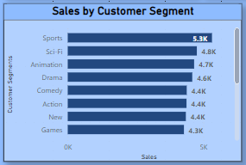Which customer segments generate the highest sales?

**INSIGHT:-**

Due to the absence of customer segmentation such as age or income in the dataset, film genres serve as substitutes for understanding customer preferences. The chart reveals the Sports segment as the most lucrative revenue contributor, underscoring the necessity of directing marketing endeavors towards high-performing segments. This emphasizes the crucial role of data-driven strategies in leveraging segment potential optimally, with the top-performing segments identified as pivotal areas for future business expansion and development. By aligning marketing initiatives with segment preferences, businesses can capitalize on revenue opportunities more effectively, driving sustained growth and market success.

**Problem Statement 3 :-**

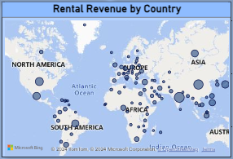**How does the rental revenue vary by country?**

**INSIGHT:-**

The chart provides insights into the fluctuation of rental revenue across various countries, with India leading as the top revenue generator, followed by the United States and China. These observations shed light on regional disparities in revenue generation, underscoring the need for tailored market development strategies. By concentrating efforts on top-performing countries like India, the United States, and China, rental businesses can leverage existing success to fuel further growth and expansion endeavors in these promising markets. This strategic approach allows businesses to capitalize on lucrative opportunities and maximize revenue potential in key geographical regions.

**Problem Statement 4 :-**

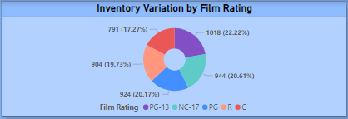How does the inventory vary by film rating?

**INSIGHT:-**

The visualization presents a comprehensive view of film inventory, revealing a nuanced reflection of viewer preferences across different content ratings. The substantial presence of PG-13 and NC-17 rated films underscores their popularity among audiences, indicating a strong demand for diverse and mature-themed content. In contrast, the comparatively lower inventory for G-rated films suggests potential challenges in attracting viewers to family-friendly content. This insight serves as a valuable guide for inventory management decisions and content acquisition strategies, highlighting opportunities to optimize the film selection to better cater to audience preferences and drive revenue growth. By leveraging these insights, businesses can tailor their offerings to align more closely with viewer preferences, ultimately enhancing customer engagement and fostering long-term success in the movie rental industry.

**Problem Statement 5 :-**

**What is the distribution of films by language?**

**INSIGHT:-**

The chart presents film distribution by language, revealing that the dataset contains only one language option. This suggests an opportunity to diversify language offerings to appeal to a broader customer base and ultimately boost revenue. By expanding language choices, rental stores can cater to diverse audience preferences, thereby enhancing customer satisfaction and driving incremental revenue growth. This proactive approach aligns with customer-centric strategies aimed at expanding market reach and maximizing profitability.

**Problem Statement 6 :-**

****What is the distribution of staff by employment duration?

**INSIGHT:-**

The visualization provides a clear depiction of the distribution of staff across various employment durations, highlighting a significant concentration of staff members within a specific tenure range. It's worth noting that the dataset comprises only two staff members, both with an employment duration of 17 years. This observation emphasizes the pressing need to augment the staff team to enhance workflow efficiency and operational effectiveness. By expanding the staff base, the organization can alleviate potential workload bottlenecks, foster a more balanced distribution of responsibilities, and ultimately improve overall productivity.

**Problem Statement 7 :-**

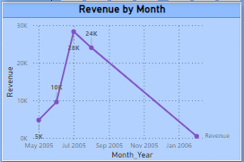How does the sales revenue vary by month?

**INSIGHT:-**

The line chart provides a comprehensive overview of sales revenue throughout 2005, showcasing a notable surge in July, aligning with the peak in film rentals during that period. However, the subsequent months witnessed fluctuating revenue, characterized by a consistent decline from September 2005 to January 2006. This cyclical pattern suggests a potential seasonal influence on film rentals, warranting a deeper analysis of consumer behavior during different times of the year. By leveraging insights from successful periods, such as the revenue peak in July, businesses can strategize effectively to enhance revenue generation and mitigate downturns during less favorable months.

**Problem Statement 8 :-**

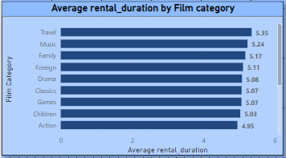**How does the average rental duration vary by film category?**

**INSIGHT:-**

The chart provides insights into the variation of average rental durations across different film categories, with Travel emerging as the category with the longest duration, followed by Music and Family categories. This observation underscores the significance of tailoring content curation strategies to align with viewer preferences and rental habits. By stocking popular genres with longer rental durations, such as Travel and Family films, rental stores can enhance customer engagement and profitability. This understanding informs decisions on inventory management and revenue optimization, ensuring a curated selection that resonates with viewers and drives sustained business success.

**Problem Statement 9 :-**

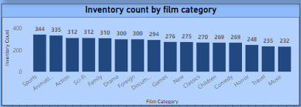What is the breakdown of film categories in the inventory?

**INSIGHT:-**

The chart provides a comprehensive overview of the film inventory, revealing a diverse array of genres and their respective prevalence within the catalog. Sport and Animation emerge as the dominant categories, suggesting a strong appeal and demand among viewers for content in these genres. Conversely, the lower representation of Travel and Music categories indicates potential opportunities for expansion or targeted promotions to increase viewer engagement with these genres. This breakdown underscores the importance of maintaining a well-rounded inventory to cater to a wide range of audience preferences and ensure customer satisfaction. By leveraging insights from this analysis, rental businesses can refine their content selection strategies, optimize inventory management practices, and ultimately enhance the overall viewing experience for their customers.

**Problem Statement 10 :-**

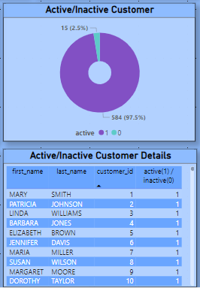Calculate Active or Inactive customers. And also give details of those customers?

**INSIGHT:-**

The pie chart offers valuable insights into customer engagement, revealing that the vast majority, around 97%, maintain active status, while approximately 2.5% are currently inactive. This distribution highlights the significance of proactive measures to re-engage dormant customers and optimize overall retention efforts. By leveraging data-driven campaigns and tailored discount offers, businesses can effectively reignite interest among inactive customers, ultimately bolstering customer loyalty and fostering sustainable growth. This strategic approach not only addresses immediate retention challenges but also cultivates long-term customer relationships, ensuring continued success in the competitive marketplace.

**Problem Statement 11 :-**

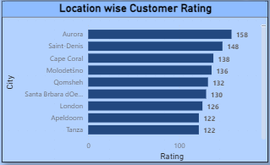**Which locations have the highest and lowest customer ratings?**

**INSIGHT:-**

The chart illustrates the distribution of customer ratings across different locations, with Aurora receiving the highest ratings and Fuzhou scoring the lowest. This observation underscores the significance of fostering knowledge-sharing and implementing performance improvement initiatives at top-rated locations to drive revenue growth. Moreover, it emphasizes the need for collaborative strategies aimed at elevating ratings in lower-performing locations, ultimately enhancing overall customer satisfaction levels across all branches. This proactive approach ensures consistent service excellence and reinforces the brand's reputation for quality and reliability across its entire network of locations.

**Problem Statement 12 :-**

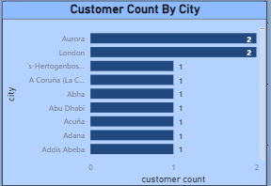**What is the distribution of customers across different cities?**

**INSIGHT:-**

The Bar chart illustrates the distribution of customers across various cities, highlighting Aurora and London as the cities with the highest customer counts, while other cities are represented by only one customer each. This observation underscores the importance of implementing targeted strategies, such as offering rental discounts, conducting promotional campaigns, and providing a diverse range of film options, to attract more customers from cities with lower representation and bolster overall customer engagement. By addressing the needs and preferences of customers in underrepresented cities, rental businesses can expand their customer base and improve overall business performance.

**Problem Statement 13 :-**

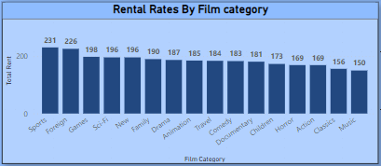**Which film categories have the highest rental rates?**

**INSIGHT:-**

The chart reveals the film categories with the highest rental rates, with Sports and Foreign categories standing out as top performers. This presents an opportunity to leverage the success of these categories by expanding the selection and optimizing revenue potential. Strategic curation of the inventory to include a wider range of titles within these high-performing categories can effectively cater to customer preferences and stimulate increased rental activity. By capitalizing on these trends, rental stores can enhance customer satisfaction and drive sustained revenue growth.

**Problem Statement 14 :-**

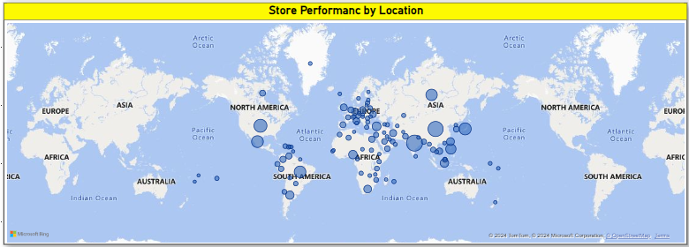How does the store performance vary by location?

**INSIGHT:-**

The visualization offers valuable insights into store performance across various locations, highlighting India and China as the top-performing regions. This data serves as a foundation for strategic decision-making aimed at enhancing the performance of underperforming stores. By pinpointing areas of excellence and identifying opportunities for improvement, the chart provides guidance for targeted initiatives to elevate overall performance levels. Furthermore, it underscores the diverse nature of store success, emphasizing the need for tailored strategies to address the unique challenges and opportunities present in each location.

**Problem Statement 15 :-**

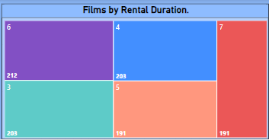What is the distribution of films by rental duration?

**INSIGHT:-**

The visualization provides valuable insights into the distribution of films based on rental duration, shedding light on viewers' preferences and habits. It reveals that rental durations spanning 3-7 months emerge as the preferred choice among viewers, suggesting a tendency towards extended viewing periods. Additionally, the data indicates a notable peak in viewership during the 6th month of rental duration, underscoring a trend towards longer-term rental engagements. This nuanced understanding of rental duration patterns offers actionable intelligence for content curation and marketing strategies, enabling businesses to tailor their offerings to better align with viewer preferences and maximize customer satisfaction.

**Problem Statement 16 :-**

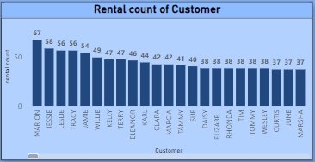**How does rental rate vary among different customer segments?**

**INSIGHT:-**

The chart providing a detailed breakdown of rental rate variations among all customers offers valuable insights into the dynamic landscape of pricing strategies and customer preferences within the movie rental sector. By meticulously analyzing rental rates across different customer segments, rental store owners can gain a deeper understanding of pricing dynamics and tailor their strategies to meet the diverse needs and preferences of their clientele. This comprehensive analysis enables rental businesses to identify pricing trends, assess the effectiveness of current pricing models, and make informed adjustments to optimize revenue generation while ensuring customer satisfaction. Additionally, by leveraging these insights, rental store owners can develop targeted marketing campaigns and promotional offers aimed at attracting and retaining customers, ultimately fostering long-term business success and growth.

**Problem Statement 17 :-**

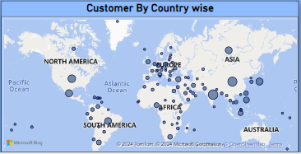**What is the breakdown of customers by country?**

**INSIGHT:-**

Analyzing customers by country provides valuable insights into geographic trends in customer distribution, offering a deeper understanding of diverse demographics and preferences across different regions. This analysis serves as a foundation for targeted marketing initiatives and service optimization strategies tailored to specific countries or regions. By identifying geographical patterns in customer behavior, rental businesses can develop more effective marketing campaigns, promotions, and personalized offerings to better resonate with local audiences. Additionally, this analysis guides strategic decisions for market expansion efforts, enabling rental businesses to capitalize on emerging opportunities and address challenges unique to each geographic market. Overall, understanding customers by country empowers rental businesses to enhance customer engagement, drive revenue growth, and strengthen their competitive position in the global marketplace.

**Problem Statement 18 :-**

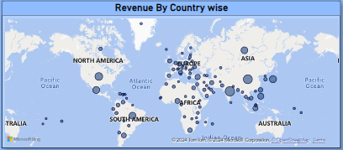**What is the breakdown of revenue by country?**

**INSIGHT:-**

The revenue breakdown by country reveals notable variations in revenue generation across different regions, with certain countries emerging as top performers, including India, the United States, and China. This insight provides valuable guidance for rental businesses, signaling potential market opportunities and areas for strategic focus. By identifying top-performing countries, rental businesses can prioritize targeted market development and expansion efforts to capitalize on existing success and drive further revenue growth. Moreover, this analysis underscores the importance of tailoring marketing strategies and service offerings to specific geographic regions to effectively meet the needs and preferences of local customers. Overall, leveraging insights from the revenue breakdown by country enables rental businesses to optimize their market approach, enhance revenue generation, and strengthen their competitive position in the global marketplace.

**Problem Statement 19 :-**

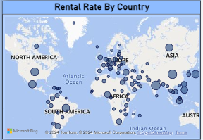**Variation of Rental Rate by Country?**

**INSIGHT:-**

The revenue breakdown by country sheds light on the diverse rental rates observed across different regions, with India emerging as the top revenue generator, followed by China, the United States, and other countries. This insight provides valuable guidance for rental businesses, offering opportunities to refine pricing strategies to maximize revenue while maintaining sustainable demand. Moreover, disparities in rental durations across countries underscore the need for tailored content acquisition and targeted marketing efforts. By understanding each country's unique viewing behaviors and preferences, rental businesses can strategically curate their inventory and promotional campaigns to better cater to local audiences, thereby driving customer engagement and revenue growth.

**Problem Statement 20 :-**

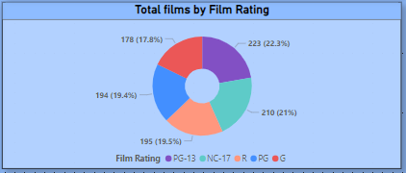**What is the distribution of films categorized by their content ratings?**

**INSIGHT:-**

The data unveils the distribution of films across different content ratings, indicating varying levels of prevalence among ratings such as PG-13 and R. This insight sheds light on diverse audience preferences and viewing demographics, offering valuable guidance for content acquisition strategies and targeted marketing efforts. By understanding the distribution of films by rating, rental businesses can tailor promotions and recommendations to specific audience segments, thereby enhancing customer satisfaction and engagement. This knowledge empowers rental stores to optimize their inventory and promotional activities to better meet the needs and preferences of their clientele.

**Problem Statement 21 :-**

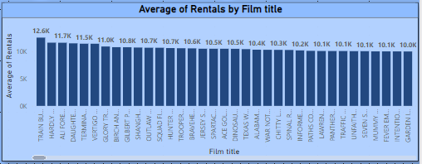What is the breakdown of film rentals based on their distribution patterns?

**INSIGHT:-**

The chart offers a comprehensive overview of film rental distribution, shedding light on customer preferences and the popularity of various films. By analyzing this data, rental store owners gain valuable insights into which films are in high demand among customers, allowing them to make informed decisions about managing their inventory and acquiring new content. This information enables strategic planning to ensure that rental stores offer a diverse and appealing selection of films that cater to the preferences of their customer base, ultimately enhancing the overall experience for movie enthusiasts. Additionally, understanding film popularity trends can help rental businesses stay ahead of market shifts and remain competitive in the dynamic entertainment industry landscape.

**Problem Statement 22 :-**

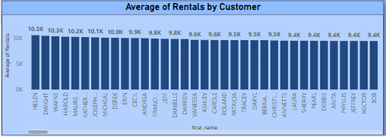What is the breakdown of rental activity by customer?

**INSIGHT:-**

The rental by customer segments chart provides valuable insights into the preferences of different customer segments, enabling businesses to tailor their marketing strategies and content offerings accordingly. By identifying which segments contribute the most to rental revenue, businesses can focus their efforts on retaining these valuable customers and exploring opportunities for expansion within these segments. This analysis not only optimizes operational efficiency but also enhances overall customer satisfaction by ensuring that rental stores offer content that aligns with the preferences of their most profitable customer segments. Ultimately, these strategic insights drive revenue growth and position businesses for long-term success in the competitive rental market.

**Problem Statement 23 :-**

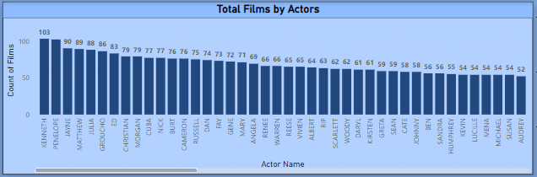How is the film distribution distributed among different actors?

**INSIGHT:-**

The chart underscores Kenneth and Penelope's significant influence in film distribution, showcasing their widespread presence across various titles, which may stem from their versatility and broad audience appeal. Conversely, Judy and Emily's limited appearances suggest an opportunity to enhance casting diversity and elevate their visibility within the industry. By diversifying casting choices and providing more opportunities for actors like Judy and Emily, filmmakers can enrich storytelling and broaden audience engagement, ultimately fostering a more inclusive and dynamic film landscape.

**Problem Statement 24 :-**

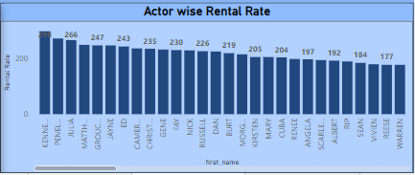How does rental rate vary among different actors?

**INSIGHT:-**

The chart elucidates variations in rental rates attributed to different actors, unveiling nuanced audience preferences and varying perceptions of value across performers. This insight serves as a valuable guide for filmmakers and content creators, informing strategic casting decisions and content optimization efforts aimed at maximizing audience engagement and revenue potential. By understanding which actors drive higher rental rates, filmmakers can tailor their casting choices and content selection to align more closely with audience preferences, thereby enhancing the overall success and profitability of their productions.

**Problem Statement 25 :-**

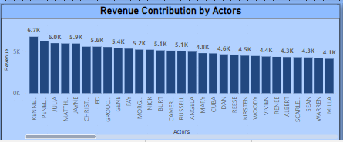Actor-wise Revenue Contribution?

**INSIGHT:-**

The analysis of revenue contributions by actors offers valuable insights into the significant financial impact of individual performers on overall film revenue. This understanding serves as a cornerstone for strategic decision-making in casting and talent management, allowing filmmakers and production houses to leverage the popularity and influence of certain actors to maximize revenue potential. By identifying which actors contribute most significantly to revenue generation, industry professionals can tailor casting choices and negotiation strategies to optimize profitability and ensure the success of their projects. Additionally, this analysis provides valuable benchmarks for assessing the relative marketability and value of different actors, informing future casting decisions and talent acquisition strategies for enhanced business performance.

**Problem Statement 26 :-**

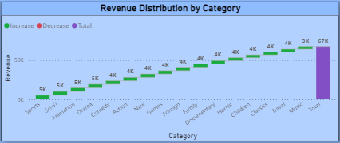Distribution of Revenue Across Film Categories?

**INSIGHT:-**

The chart highlights the dominance of the Port and Sci-Fi categories in revenue generation, reflecting strong audience demand for these genres. This underscores the importance of deploying targeted marketing campaigns and offering curated content to capitalize on the popularity of these lucrative categories. However, the Travel and Music categories show lower revenue contributions, indicating potential challenges in attracting audiences to these genres. To address this, strategies such as enhancing content appeal, refining marketing tactics, or exploring partnerships with artists or travel companies could help bolster revenue in these segments. By understanding the revenue dynamics across different categories, businesses can tailor their content offerings and marketing strategies to maximize revenue generation and better meet the diverse preferences of their audience.

**Problem Statement 27 :-**

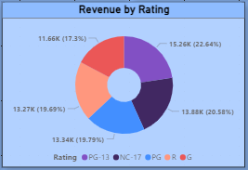How does revenue vary across different film ratings?

**INSIGHT:-**

The revenue distribution by film rating highlights significant revenue generation from PG and NC-17 rated films, indicative of robust audience demand for diverse or mature-themed content. This presents opportunities for businesses to implement targeted marketing strategies and curate selections that cater to these popular ratings, thereby maximizing revenue potential. Conversely, G-rated films exhibit the lowest revenue contribution, suggesting challenges in attracting audiences to family-friendly content. To address this, businesses may need to implement strategic promotions or diversify their content offerings to enhance revenue in this category. By understanding the revenue dynamics associated with different film ratings, businesses can optimize their content strategies to better align with audience preferences and drive overall revenue growth.

**Problem Statement 28 :-**

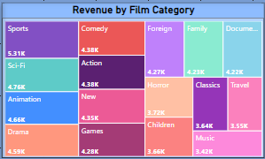What is the revenue distribution by film category, and which categories contribute the most to revenue?

**INSIGHT:-**

The chart provides valuable insights into film distribution by rental duration, revealing that durations ranging from 3 to 7 months are the most favored among viewers, aligning closely with their typical viewing habits. Additionally, the data identifies the 6th month of rental duration as the peak period for viewership, indicating a preference for longer-term rental engagements. This trend underscores the importance of offering rental options that accommodate viewers' preferences for extended viewing periods, potentially influencing content acquisition and marketing strategies to cater to this trend.

**POWER BI DASHBOARDS**

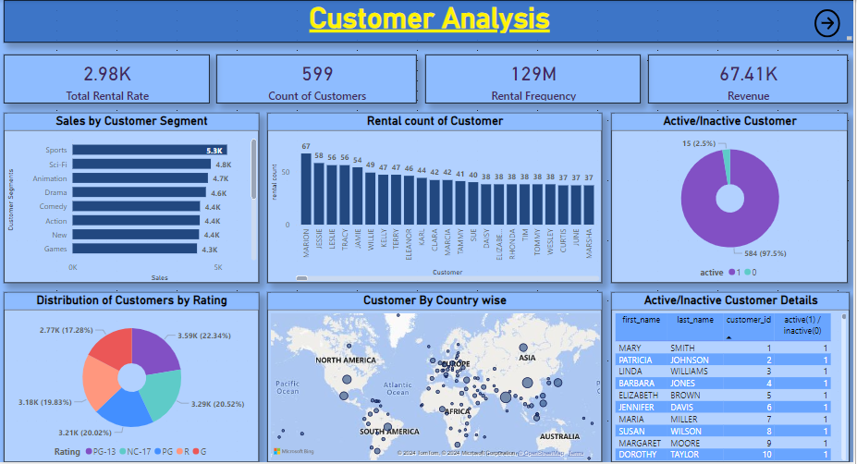

**POWER BI DASHBOARDS**

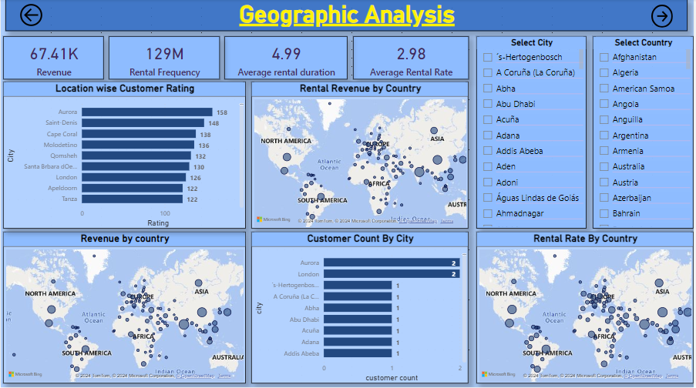

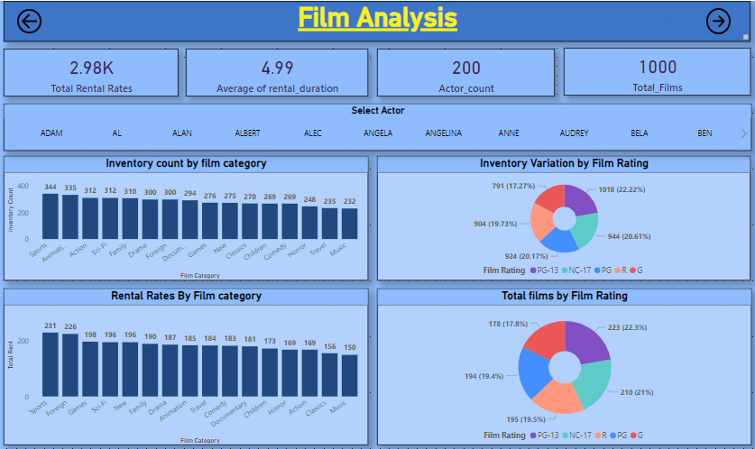

**POWER BI DASHBOARDS**

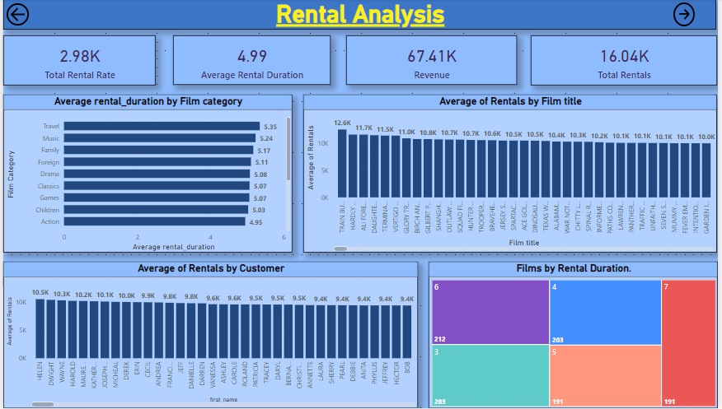

**POWER BI DASHBOARDS**

**POWER BI DASHBOARDS**

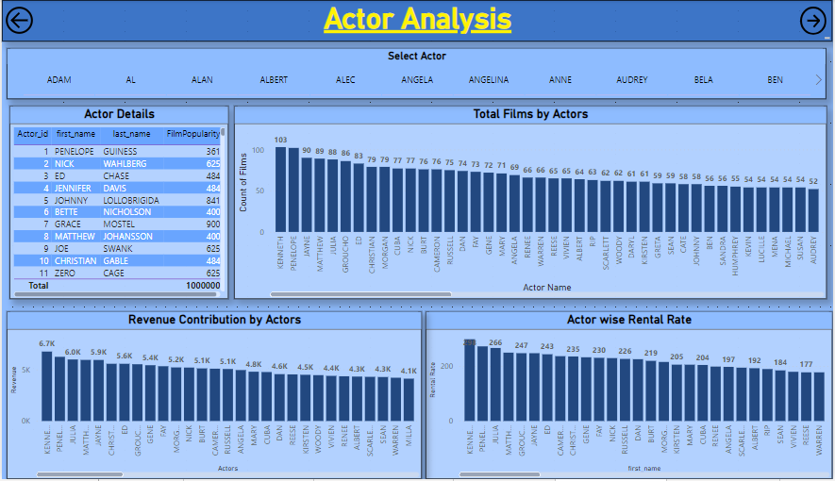

**POWER BI DASHBOARDS**

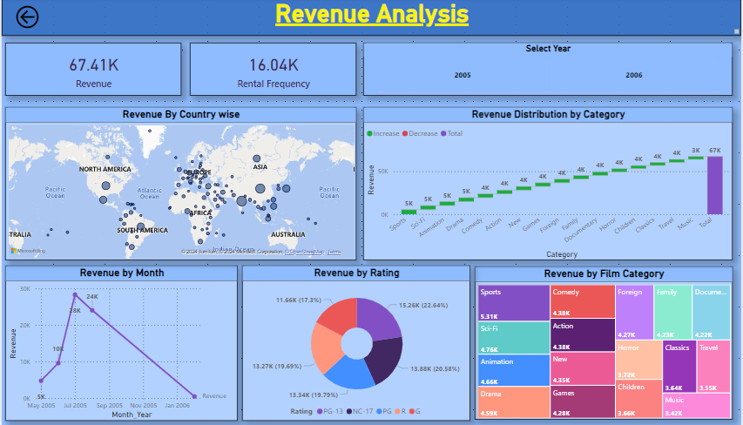

**CONCLUSION**

The progression of this project has been transformative, navigating through crucial phases that ultimately led to a comprehensive analysis of the Sakila DVD Rental Store Database. From the initial data gathering to the meticulous exploratory data analysis (EDA) and the subsequent creation of insightful Power BI visualizations, each step has significantly contributed to the project's success.

Beginning with the foundational phase of data acquisition, sourcing the dataset from the Github repository laid the groundwork for extracting valuable insights into the rental store business. The dataset, with its complex structure comprising multiple tables and relationships, provided a rich and diverse dataset for analysis.

As the analysis delved deeper into the data during the exploratory data analysis (EDA) phase, compelling insights into customer behavior, film inventory management, and store operations emerged. Leveraging SQL queries proved instrumental in uncovering patterns, trends, and relationships within the dataset. Further visualization of these insights using Excel enhanced understanding and facilitated actionable recommendations.

The integration of Power BI into the project marked a pivotal moment, offering a dynamic platform for visual storytelling. Power BI dashboards facilitated the creation of engaging visualizations that offered in-depth exploration of customer segmentation, sales trends, film performance, staff productivity, and store revenue. These visualizations served as a bridge between raw data and actionable insights.

The journey traversed various phases, each contributing to a deeper understanding of the rental store business landscape. From identifying top-rented films to analyzing the influence of film categories and customer behavior, each analysis provided stepping stones toward achieving the project's overarching objectives.

In conclusion, this project underscores the significance of data-driven decision-making in shaping strategic outcomes. It emphasizes the importance of leveraging insights to optimize film inventory, enhance customer satisfaction, improve staff performance, and streamline store operations. The actionable insights derived from this project serve as a strategic roadmap for rental store owners, guiding them towards success in the competitive DVD rental market.

By harnessing the knowledge extracted from the Sakila DVD Rental Store Database, businesses can embark on a journey of continuous improvement, utilizing data to drive success, profitability, and customer satisfaction.